Week 1 results

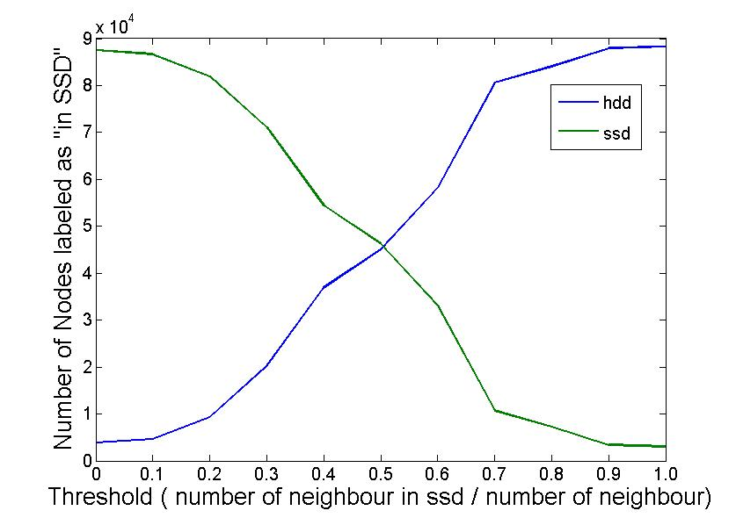

* The threshold is capable to control the placement
* The majority nodes of the graph are connected
* The algorithm converges pretty fast, the detailed results below shows how the placement changes for each iteration of each preset threshold.  
  Although it still require further experiments to see if it can meet the requirement of online algorithm for fast changing graphs.
* The placement decision of each node only requires the information of the portion of neighbors which are in ssd. That is, only the number is required, the node does not need to know which neighbors are in ssd. So the communication overhead can be greatly reduced. Potential for a distributed algorithm.

Graph details: Directed Multigraph

Nodes: 91420

Edges: 19773336

Zero Deg Nodes: 1619

Zero InDeg Nodes: 1619

Zero OutDeg Nodes: 1619

NonZero In-Out Deg Nodes: 89801

Seeds selection method: 0

Number of Seeds: 100

On iteration 1

with threshold 0

Number of SSD: 86857

Number of HDD: 4463

On iteration 2

with threshold 0

Number of SSD: 87331

Number of HDD: 3989

On iteration 3

with threshold 0

Number of SSD: 87409

Number of HDD: 3911

On iteration 4

with threshold 0

Number of SSD: 87449

Number of HDD: 3871

On iteration 5

with threshold 0

Number of SSD: 87484

Number of HDD: 3836

On iteration 1

with threshold 0.1

Number of SSD: 84417

Number of HDD: 6903

On iteration 2

with threshold 0.1

Number of SSD: 86321

Number of HDD: 4999

On iteration 3

with threshold 0.1

Number of SSD: 86581

Number of HDD: 4739

On iteration 4

with threshold 0.1

Number of SSD: 86644

Number of HDD: 4676

On iteration 5

with threshold 0.1

Number of SSD: 86685

Number of HDD: 4635

On iteration 1

with threshold 0.2

Number of SSD: 73144

Number of HDD: 18176

On iteration 2

with threshold 0.2

Number of SSD: 76955

Number of HDD: 14365

On iteration 3

with threshold 0.2

Number of SSD: 81696

Number of HDD: 9624

On iteration 4

with threshold 0.2

Number of SSD: 81827

Number of HDD: 9493

On iteration 5

with threshold 0.2

Number of SSD: 81943

Number of HDD: 9377

On iteration 1

with threshold 0.3

Number of SSD: 59300

Number of HDD: 32020

On iteration 2

with threshold 0.3

Number of SSD: 65729

Number of HDD: 25591

On iteration 3

with threshold 0.3

Number of SSD: 70004

Number of HDD: 21316

On iteration 4

with threshold 0.3

Number of SSD: 70941

Number of HDD: 20379

On iteration 5

with threshold 0.3

Number of SSD: 71138

Number of HDD: 20182

On iteration 1

with threshold 0.4

Number of SSD: 48277

Number of HDD: 43043

On iteration 2

with threshold 0.4

Number of SSD: 53354

Number of HDD: 37966

On iteration 3

with threshold 0.4

Number of SSD: 54070

Number of HDD: 37250

On iteration 4

with threshold 0.4

Number of SSD: 54306

Number of HDD: 37014

On iteration 5

with threshold 0.4

Number of SSD: 54401

Number of HDD: 36919

On iteration 1

with threshold 0.5

Number of SSD: 31757

Number of HDD: 59563

On iteration 2

with threshold 0.5

Number of SSD: 38954

Number of HDD: 52366

On iteration 3

with threshold 0.5

Number of SSD: 42461

Number of HDD: 48859

On iteration 4

with threshold 0.5

Number of SSD: 45130

Number of HDD: 46190

On iteration 5

with threshold 0.5

Number of SSD: 46276

Number of HDD: 45044

On iteration 1

with threshold 0.6

Number of SSD: 24320

Number of HDD: 67000

On iteration 2

with threshold 0.6

Number of SSD: 27962

Number of HDD: 63358

On iteration 3

with threshold 0.6

Number of SSD: 29344

Number of HDD: 61976

On iteration 4

with threshold 0.6

Number of SSD: 30237

Number of HDD: 61083

On iteration 5

with threshold 0.6

Number of SSD: 33036

Number of HDD: 58284

On iteration 1

with threshold 0.7

Number of SSD: 9957

Number of HDD: 81363

On iteration 2

with threshold 0.7

Number of SSD: 10584

Number of HDD: 80736

On iteration 3

with threshold 0.7

Number of SSD: 10713

Number of HDD: 80607

On iteration 4

with threshold 0.7

Number of SSD: 10742

Number of HDD: 80578

On iteration 5

with threshold 0.7

Number of SSD: 10744

Number of HDD: 80576

On iteration 1

with threshold 0.8

Number of SSD: 6922

Number of HDD: 84398

On iteration 2

with threshold 0.8

Number of SSD: 7189

Number of HDD: 84131

On iteration 3

with threshold 0.8

Number of SSD: 7219

Number of HDD: 84101

On iteration 4

with threshold 0.8

Number of SSD: 7236

Number of HDD: 84084

On iteration 5

with threshold 0.8

Number of SSD: 7237

Number of HDD: 84083

On iteration 1

with threshold 0.9

Number of SSD: 3336

Number of HDD: 87984

On iteration 2

with threshold 0.9

Number of SSD: 3367

Number of HDD: 87953

On iteration 3

with threshold 0.9

Number of SSD: 3369

Number of HDD: 87951

On iteration 4

with threshold 0.9

Number of SSD: 3371

Number of HDD: 87949

On iteration 5

with threshold 0.9

Number of SSD: 3372

Number of HDD: 87948

On iteration 1

with threshold 1

Number of SSD: 3049

Number of HDD: 88271

On iteration 2

with threshold 1

Number of SSD: 3049

Number of HDD: 88271

On iteration 3

with threshold 1

Number of SSD: 3049

Number of HDD: 88271

On iteration 4

with threshold 1

Number of SSD: 3049

Number of HDD: 88271

On iteration 5

with threshold 1

Number of SSD: 3049

Number of HDD: 88271